Dear Team,
Following recent design work and discussions, this note provides a detailed, consolidated product brief for the next phase of the HarvestPlus platform (powered by YDEN). The goal is to evolve HarvestPlus from a dairy-only ERP into a multi-commodity aggregation, planning, quality, and settlement platform, starting with Dairy, Coffee, Cereals, and other non-perishables.
This document should be treated as a build specification and architectural guide.

1. Product Vision (What We Are Building)
HarvestPlus is becoming a commodity operating system for Rwanda’s agriculture value chains, supporting:
- Smallholder farmers
- Agents / Abacunda
- Collection Centers (MCCs, coffee washing stations, warehouses)
- Quality & compliance officers
- Payments & financing (Ikofi integration)
Key principle:
One core platform + configurable commodity logic (no hard-coding).

2. Core Architectural Concept: “Commodity Studio”
We are introducing an Admin-level configuration module called Commodity Studio, which allows non-developers (admins) to:
- Create new commodity categories
- Define new commodities
- Configure quality checks dynamically
- Set commodity-specific collection frequency
- Define input catalogs and seasons
This avoids rebuilding the platform for every new commodity.

3. Admin Module: Commodity Studio (MUST BUILD)

3.1 Commodity Categories
Admin can create categories such as:
- Perishables (Dairy, Fish, Horticulture)
- Semi-Perishables (Coffee)
- Non-Perishables (Cereals, Pulses, Oilseeds)
Fields
- Category name
- Description
- Default storage type
- Status (active/inactive)

3.2 Commodity Definition
Each commodity (e.g. Milk, Coffee Cherries, Maize) must be configurable.
General Settings
- Commodity name
- Category
- Unit of measure (liters, kg, bags)
- Pricing method:
  - Spot
  - Grade-based
  - Deferred / post-sale
- Storage type (tank, bags, silo, warehouse)
- Default collection center type

3.3 Dynamic Quality Schema Builder
Admins must be able to define quality fields without code changes.
Quality Field Properties
- Field name (e.g. Fat %, Moisture %, Grade)
- Data type:
  - Numeric
  - Dropdown
  - Boolean
  - Indicator
- Threshold rules (pass/fail/conditional)
- Impact on pricing (optional)
- Mandatory vs optional
Each commodity loads its own quality form dynamically at:
- MCC intake
- Quality review screens

3.4 Frequency & Season Settings
Each commodity has a default recording cadence:
Examples:
- Dairy: daily
- Coffee: seasonal + weekly during harvest
- Cereals: seasonal + harvest window
Admins can define:
- Seasons (A/B/C or custom)
- Expected harvest windows
- Collection frequency
- Region-specific calendars

3.5 Inputs Catalog (Farm-Level)
Admins define inputs per commodity:
Examples:
- Dairy: feed, vet, AI, minerals
- Coffee: seedlings, fertilizer, labor
- Cereals: seed, fertilizer, pesticides
Each input has:
- Category
- Unit
- Optional pricing reference

4. Farm-Level Data Module (NEW)
This module sits before collection and feeds forecasting, finance, and analytics.

4.1 Farmer Profile
Must store:
- National ID (mandatory)
- Phone number
- Location (admin hierarchy)
- Assigned agent(s)
- Default collection center
- Payment method (Ikofi / MoMo / bank)

4.2 Season Plans (Commodity-Based)
Farmers (or agents) create Season Plans:
Fields:
- Commodity
- Season
- Plot / herd reference
- Expected harvest volume
- Expected harvest dates
- Frequency (auto-filled from commodity, but editable)
This enables:
- Expected vs actual tracking
- Input financing logic
- Agent planning

4.3 Input Usage Logging
Inputs are logged against:
- Farmer
- Season plan
- Commodity
Used later for:
- Productivity analytics
- Credit scoring
- Extension services

5. Agent & Prepayment Logic (Critical)
The system must support agent prepayments to farmers before delivery.

Rules
- Agent records advance payment at farm level
- Advance is linked to:
  - Farmer ID
  - Commodity
  - Batch
- At settlement:
  - Total value – agent advance = net payout

Enforcement
- No payout if farmer ID not verified
- Full audit trail required

6. Identity & ID Enforcement (Non-Negotiable)

Mandatory IDs
- Farmer: National ID
- Agent: National ID + Agent ID
- All payouts must be tied to verified profiles

UI Requirements
- Clear “Verified / Not Verified” states
- Block payment approval if ID missing
- Store verification timestamp

7. Payments & Finance
The payments module must:
- Handle split settlements (farmer vs agent)
- Support:
  - Full payment
  - Partial (advance already paid)
- Integrate with Ikofi APIs
- Maintain ledger entries per commodity

8. Key Screens to Implement (Phase 1)

Admin
- Commodity Studio – Categories
- Commodity Studio – Define Commodity
- Quality Schema Builder
- Frequency & Season Manager
- Inputs Catalog Manager

Operations
- Agent Collection App (commodity-aware)
- MCC Intake Screen (dynamic quality forms)
- Quality Review Screen
- Inventory / Storage Screen

Finance
- Payout Review (with advance deduction)
- Payment Approval & Execution

9. Non-Functional Requirements
- Offline-first for agents
- Config-driven UI (no hard-coded commodities)
- Audit logs for payments & quality changes
- Role-based access control
- Multi-tenant ready (future scale)

10. Expected Outcome
With this architecture, the platform should be able to:
- Add a new commodity in <1 day
- Support multiple value chains without rewrites
- Power aggregation, finance, and compliance
- Position GEMURA as national agri-infrastructure

Please review and come back with:
- Proposed data model changes
- API implications
- Phasing & delivery plan
- Any technical constraints

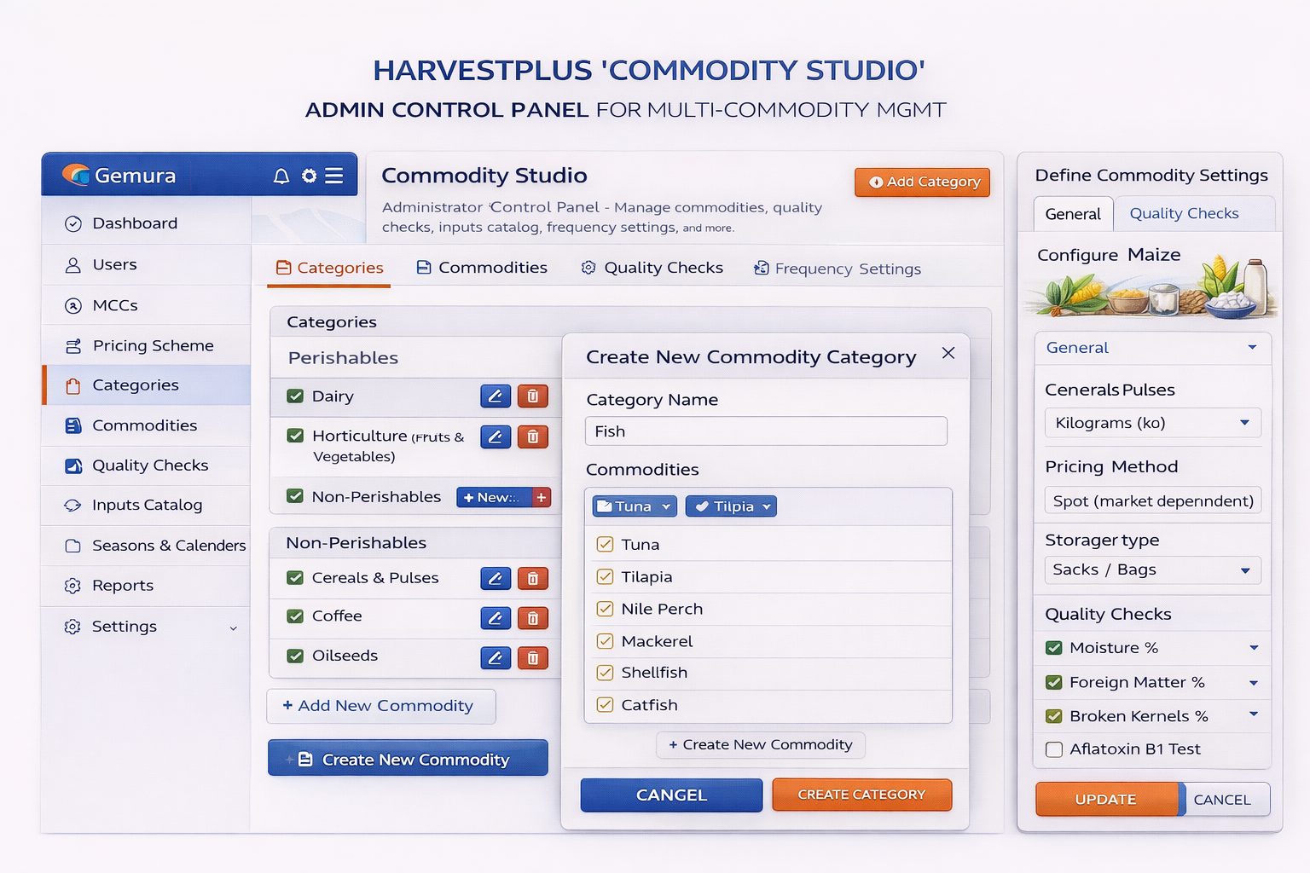

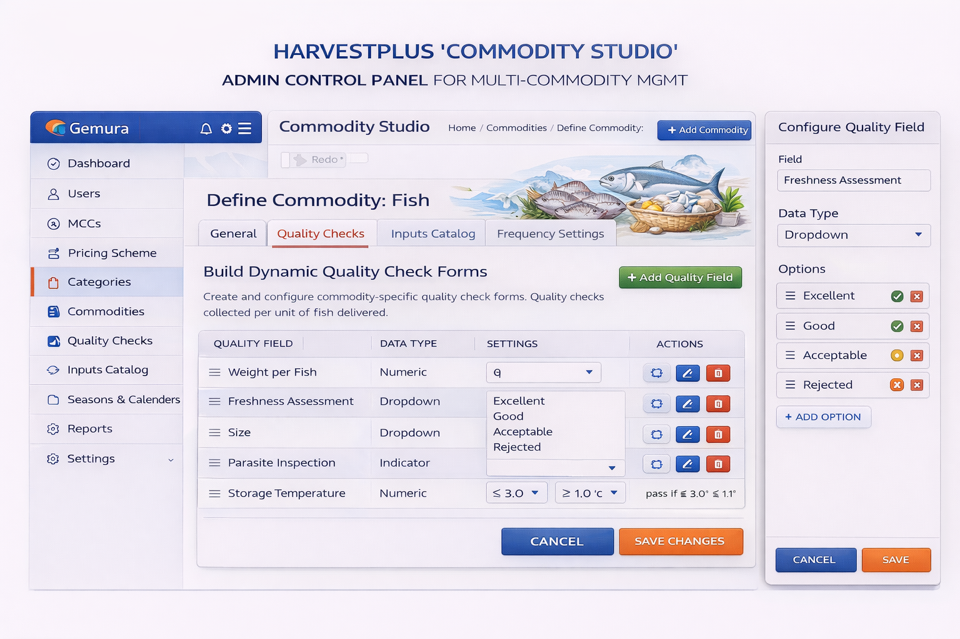
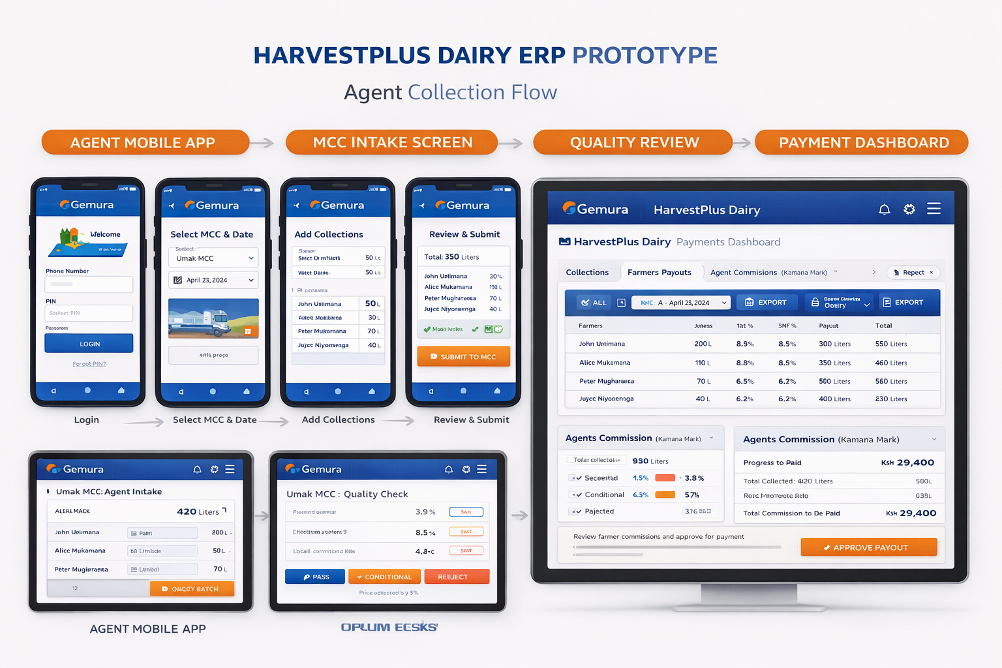
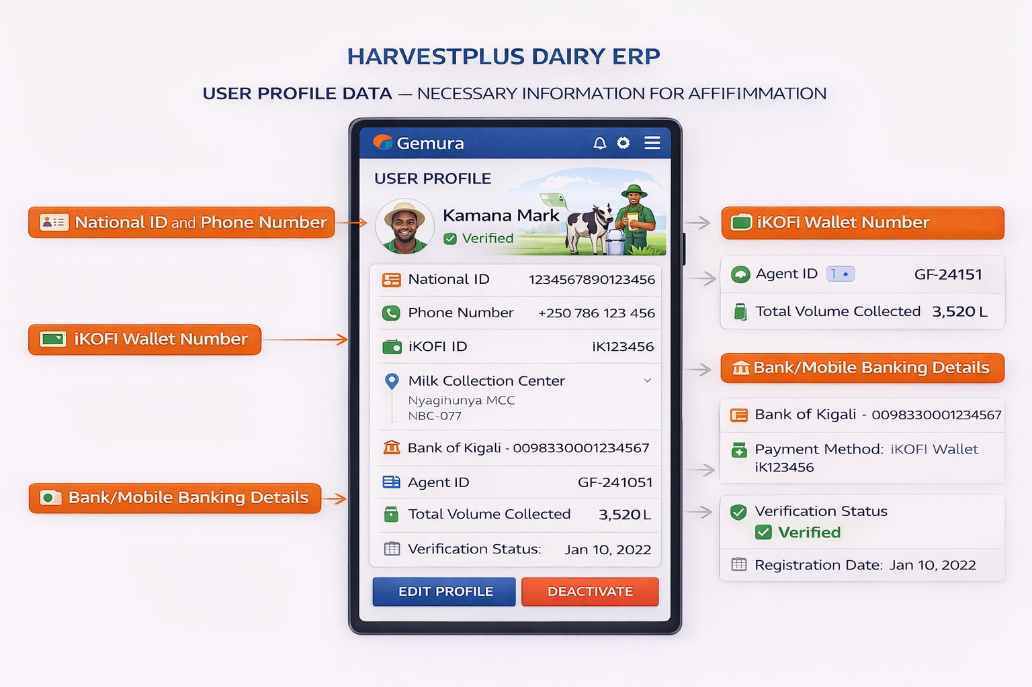
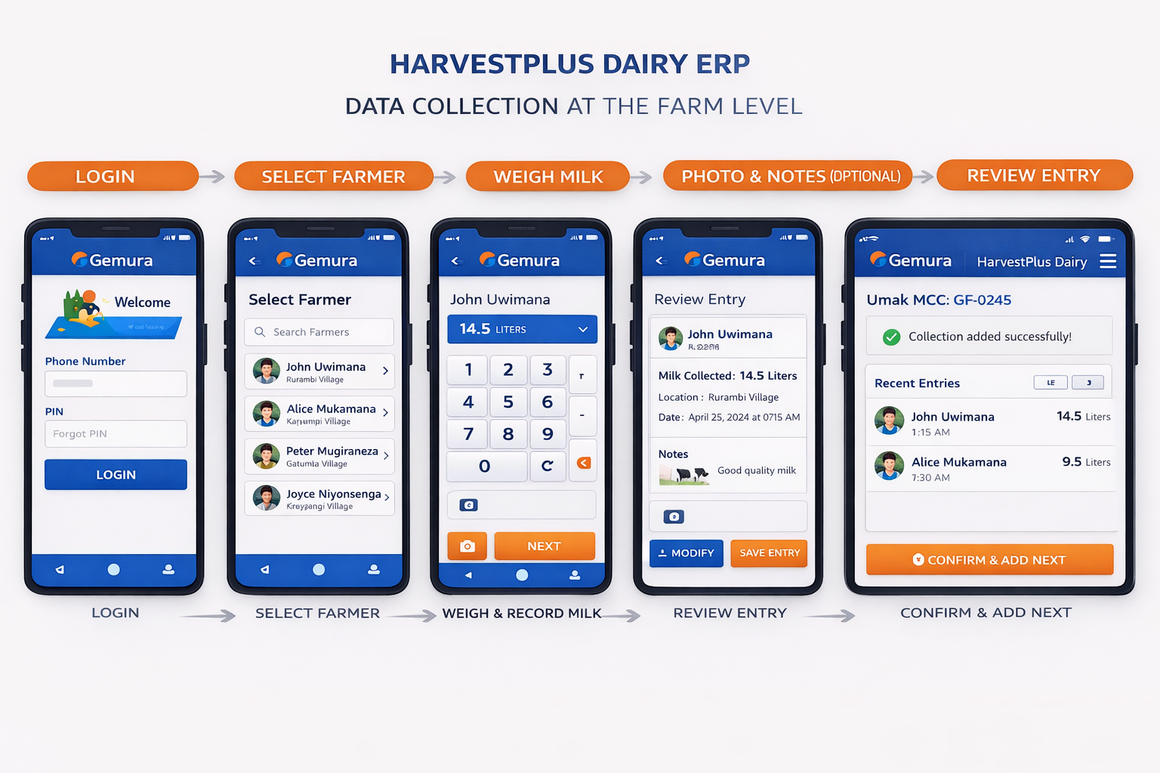

HarvestPlus → Multi-Commodity Aggregation Platform
(Dairy, Coffee, Cereals & Other Non-Perishables)

1. Core Design Principle (Very Important)
👉 One platform, multiple commodity “profiles”
Instead of building separate systems for dairy, coffee, cereals:
- You build one aggregation & settlement engine
- Each commodity plugs in via commodity-specific rules
Think:
Common backbone + commodity-specific logic

2. What Stays COMMON Across All Commodities
These modules do not change whether it’s milk, coffee, or maize.

A. Actors & Roles (Same for All)
- Farmer / Producer
- Agent / Aggregator (Abacunda)
- Collection Center
- Quality Officer
- Warehouse / Storage Officer
- Finance & Payments
- Buyer / Offtaker
- Regulator (read-only)

B. Core Platform Modules (Reusable)
Module | Dairy | Coffee | Cereals
User Profiles & IDs | ✅ | ✅ | ✅
Agent Management | ✅ | ✅ | ✅
Collection Records | ✅ | ✅ | ✅
Quality Assessment | ✅ | ✅ | ✅
Inventory / Storage | ✅ | ✅ | ✅
Pricing & Grading | ✅ | ✅ | ✅
Payments & Advances | ✅ | ✅ | ✅
Analytics & Reports | ✅ | ✅ | ✅
This is your GEMURA backbone.

3. Where Commodities DIFFER (Plug-in Logic)
Each commodity has its own “Collection Profile”.

A. DAIRY (Perishable, High Frequency)

Collection Unit
- Liters (daily, sometimes twice a day)

Quality Metrics
- Fat %
- SNF %
- Density
- Temperature
- Adulteration

Storage
- Chilled tanks
- Time-sensitive (hours)

Pricing
- Quality-based, dynamic

B. COFFEE (Semi-perishable, Seasonal)

Collection Unit
- Kg of cherries / parchment / green beans

Quality Metrics
- Moisture %
- Defects
- Grade (A1, A2, B)
- Cup score (later stage)

Storage
- Drying beds
- Warehouses
- Lot-based traceability

Pricing
- Grade-based
- Often delayed final pricing
- Premiums after export / auction

C. CEREALS (Non-Perishable)

Collection Unit
- Kg / bags

Quality Metrics
- Moisture %
- Foreign matter %
- Broken grains
- Aflatoxin (for maize)

Storage
- Silos / warehouses
- Long-term inventory

Pricing
- Grade + market price
- Can be spot or deferred

4. How This Looks in the SYSTEM (Very Important)

1️⃣ Commodity Selection (Top of Every Flow)
When an agent starts a collection:
Select Commodity:
◉ Dairy
◯ Coffee
◯ Maize
◯ Beans
◯ Rice

This auto-loads:
- Units
- Quality fields
- Pricing logic
- Storage type

2️⃣ Collection Screen (Dynamic Fields)
Example: Coffee vs Dairy
Field | Dairy | Coffee
Quantity | Liters | Kg
Temperature | ✅ | ❌
Moisture % | ❌ | ✅
Fat / SNF | ✅ | ❌
Grade | ❌ | ✅
Lot ID | ❌ | ✅
👉 Same screen, different schema

3️⃣ Quality Review (Commodity-Aware)
Quality officer sees:
- Dairy quality panel OR
- Coffee grading panel OR
- Cereals contamination panel
All flow into:
- Quality score
- Pricing tier

5. Agent Advances & IDs (Still Works Across Commodities)
Your earlier logic extends perfectly:

Agent Pre-Pays Farmer:
- Record advance payment
- Link to farmer ID
- Link to commodity batch
At settlement:
Final Value – Agent Advance = Net Payable

This applies to:
- Milk
- Coffee cherries
- Maize bags
Same logic, different volumes.

6. Inventory & Warehousing (Key Expansion)

New Module: Commodity Warehousing
- Dairy → tanks
- Coffee → lots
- Cereals → silos / bagged inventory
Each batch has:
- Commodity
- Grade
- Quantity
- Location
- Owner (farmer / agent / MCC)
- Financing status (important later)

7. Payments, Financing & Ikofi (Big Opportunity)
Once multi-commodity exists:

You unlock:
- Input advances (before harvest)
- Agent working capital
- Warehouse receipt financing
- Coffee pre-export finance
All tied to:
- Verified IDs
- Verified volumes
- Verified quality
This is where GEMURA becomes infrastructure, not just software.

8. Regulatory & Traceability Advantage
Especially for:
- Coffee exports
- Food safety
- AfCFTA traceability
You can generate:
- Farmer-level traceability
- Batch-level export records
- Compliance dashboards

9. How I’d Brand This (Important)
Instead of:
HarvestPlus Dairy ERP
Move to:

HarvestPlus by GEMURA
Multi-Commodity Aggregation & Settlement Platform
With sub-verticals:
- HarvestPlus Dairy
- HarvestPlus Coffee
- HarvestPlus Grains

